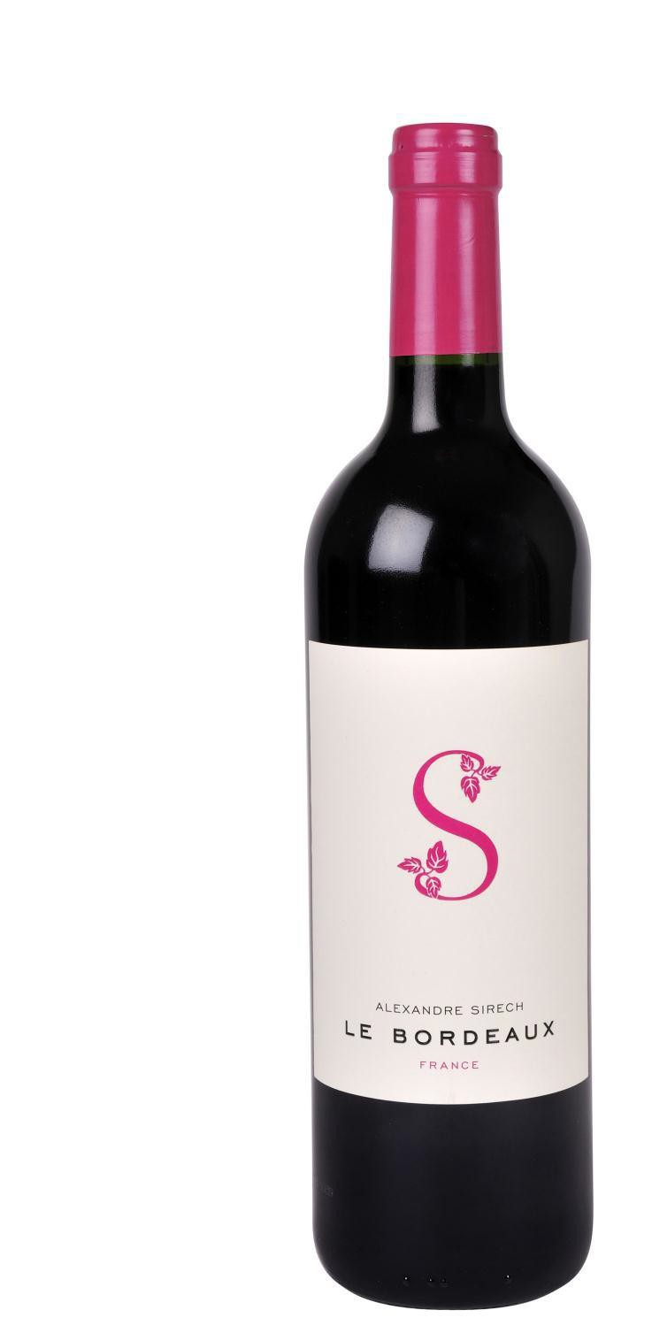
Le Bordeaux
Merlot – Cabernet Franc

Appellation: Bordeaux, &South East of France
Alcohol: 12,5% by Vol. Winery: Alexandre Sirech

Total blending freedom to attain the optimum quality. We do not hesitate to blend the finest wines from different French regions to achieve the ideal equilibrium.
This is our special expertise.

Winemaking:

From a wonderful vineyard in the village of Puisseguin-Saint-Emilion, this is a classic "Right Bank" Bordeaux wine with a composition of Merlot & Cabernet Franc.
Pre-fermentation maceration. Temperature controlled fermentation and thermo-vinification.
Stabilized by electrodialysis to prevent the formation of tartrate crystals.

Tasting notes:

Lustrous dark red color, intense and brilliant. The bouquet is full of rich red fruits. Cherries, blackberries, and blackcurrants mingle with hints of vanilla and toast.
In the mouth the taste is mellow and succulent. Elegance and freshness blend perfectly. These, combined to delicate tannins, make this wine an ideal partner for poultry, roasts and grilled meats, as well as ripe, fat cheeses.

UPC 827599900920
CASE CONTENT: 12x750ML CASE WEIGHT: 37 Lb.
CASE QTY per pallet LAYER: 14 (70 total)

T. 704 638-0004 | email: sales@ecovalleyimports.com | www.ecovalleyimports.com

