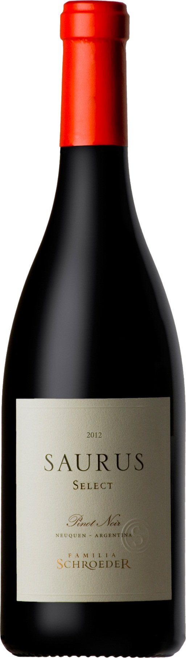

**Winemaking**:

Picked by hand. Hand selection of bunches in vibratory table. Alcoholic fermentation in stainless steel tanks with selected enzymes and yeasts. Whole grain, three days’ maceration time at low temperature, then eight-day fermentation and finally four-day maceration at low temperature. Malolactic fermentation 60% in stainless steel tanks and 40% in oak barrels. 40% aged for 9 months in new French and American oak barrels (medium and medium plus toasted) and 60% stored in stainless steel tanks to keep the fruit.

**Tasting notes:**

The sight features bright red tones. This Pinot Noir is plenty of floral aromas, like roses and violets, combined with red fruit scents such as red currants, raspberries and strawberries. Mushrooms and mineral aromas stand out together with some vanilla and cocoa notes, due to aging in oak barrels. Medium-bodied red, of ultrafine tannins and fruity nuances that wave through a finish of superior depth and dimension.

**UPC 8-77497-00003-1**

**CASE CONTENT: 6x750ML**

**CASE WEIGHT: 19,5 Lb.**

**CASE QTY per pallet LAYER: 22 (110 total)**

***Appellation****: Patagonia - Argentina*

***Vintage:*** *Current*

***Alcohol:*** *14,0% by Vol.*

***Winery:*** *Familia Schroeder*

***Winemaker:*** *Leonardo Puppato*

Saurus Select

**Pinot Noir**

T. 704 638-0004 | email: sales@ecovalleyimports.com | www.ecovalleyimports.com

