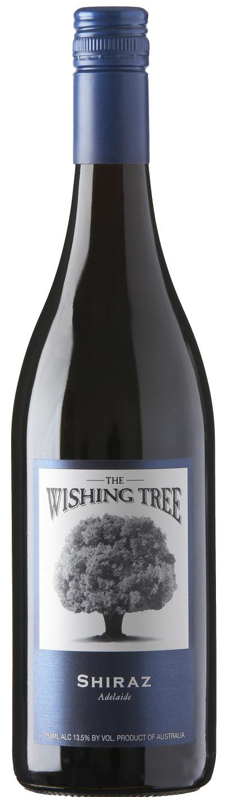
The Wishing Tree
Shiraz

Appellation: Adelaide - Australia
Alcohol: 14,0% by Vol.
Winery: Nick Haselgrove Wines

“The name The Wishing Tree comes from childhood days. As children, we were convinced by our parents that if we made a wish under this beautiful old Oak tree, it would become true.
As I recall it did work on occasion!” – Nick Haselgrove

Winemaking:

All fruit sourced from established vineyards in the Greater Appellation of "Adelaide”, which incorporates the Appellations of Barossa & Clare Valley's, McLaren Vale & the Adelaide Hills.

The Shiraz vineyard sources span 4 different Appellations, resulting in real mélange of aromas & flavors.

Tasting notes:

Deep cherry red. The fresh lifted mulberry / raspberry fruit and light mocha scent is nicely weighted by subtle oak. Medium bodied with fresh, crisp acidity and nice length of fruit. Persistent finish

UPC 827599900920
CASE CONTENT: 12x750ML CASE WEIGHT: 37 Lb.
CASE QTY per pallet LAYER: 14 (70 total)

T. 704 638-0004 | email: sales@ecovalleyimports.com | www.ecovalleyimports.com

