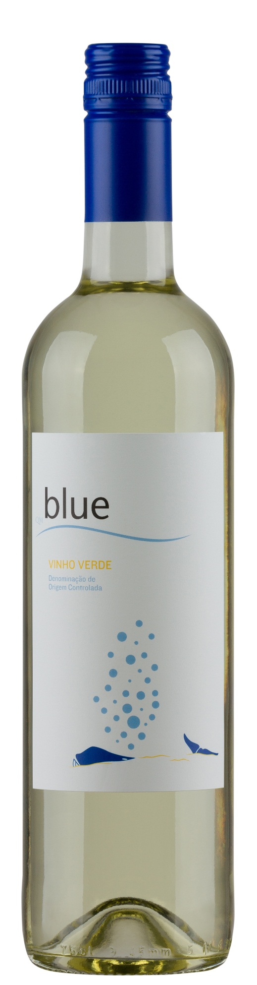

**Winemaking**:

Soft pressing and decanting for 8 to 12 hours under controlled temperatures 12ºC - 16ºC. Fermentation for 15 days under controlled temperatures 16ºC – 18ºC.

Maturation in stainless steel vats under controlled temperature and regular movement of the lees during one month.

**Tasting notes:**

Bright color with pineapple aromas followed by citrus notes. It is clean and crisp with great acidity, fruit balance and a refreshing finish.

**UPC 8-55365-00521-0**

**CASE CONTENT: 12x750ML**

**CASE WEIGHT: 31 Lb.**

**CASE QTY per pallet LAYER: 15 (75 total)**

***Appellation****: Alvaredo DOC Vinhos Verdes- Portugal*

***Alcohol:*** *11,0% by Vol.*

***Winery:*** *Quintas de Melgaço*

***Winemaker:*** *Virgínia Raínho*

Blue

**Alvarinho - Trajadura**

T. 704 638-0004 | email: sales@ecovalleyimports.com | www.ecovalleyimports.com

