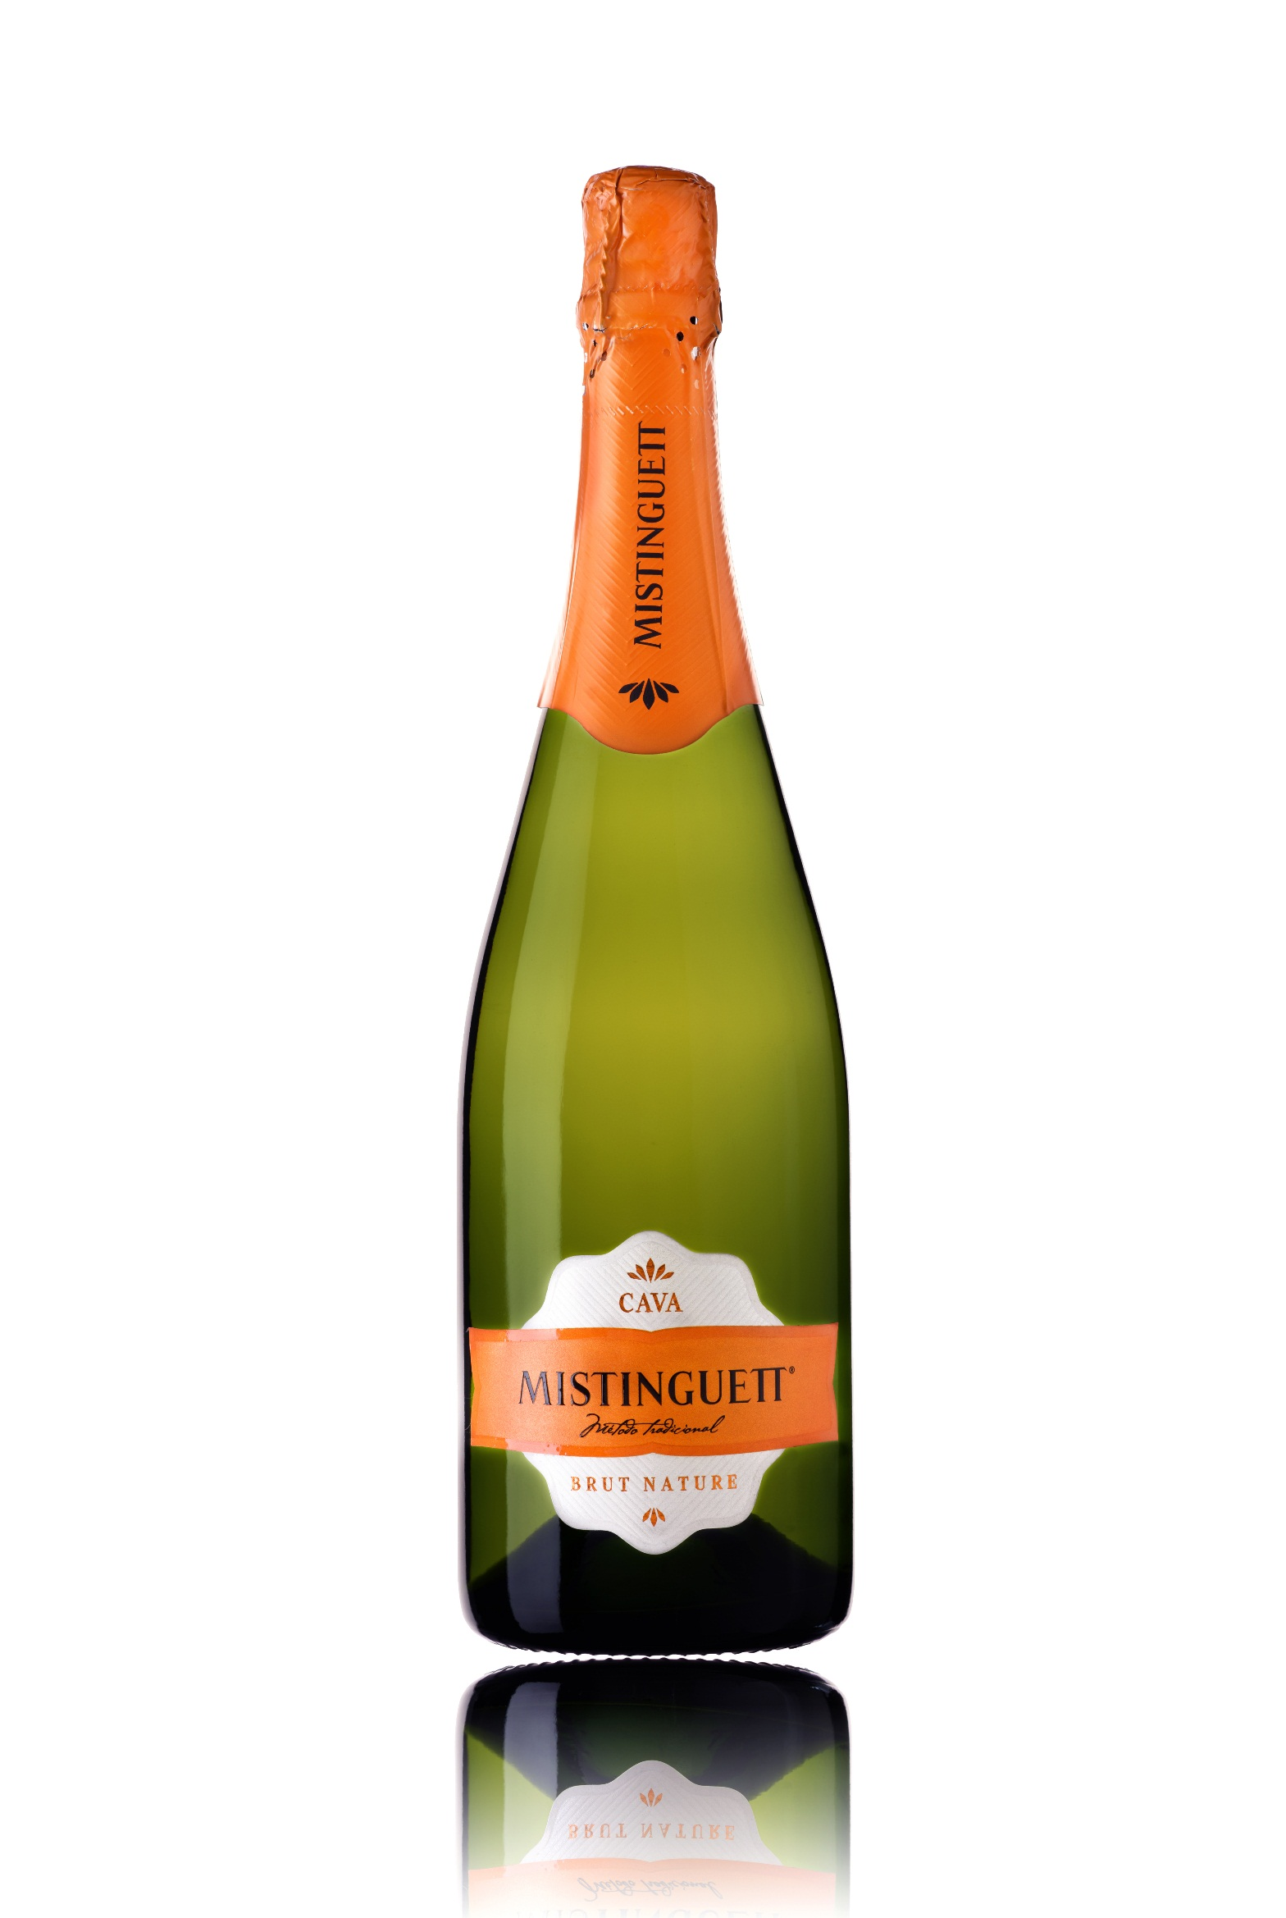

**Winemaking**:

Manual and mechanical harvest. Macabeo: 1st week of September. Xarel·lo: 2nd and 3rd weeks of September. Parellada: 1st week of October.

First fermentation in stainless steel tanks at a controlled temperature of 16ºC. 2nd in bottle using the Traditional Method. Aged 12 months in bottle.

**Tasting notes:**

Pale yellow with greenish glints, fine bubbles and formation of a white, rich and lively crown.

Traditional green apple, pear and grapefruit aroma. Mature, with almond notes.

Extensive and polished on the palate, very dry. Its finish highlights the vintage bouquet, persistent and unique in its class.

**UPC 8-53646-00434-1**

**CASE CONTENT: 12x750ML**

**CASE WEIGHT: 42,5 Lb.**

**CASE QTY per pallet LAYER: 11 (55 total)**

***Appellation****: Vilobí de Penedes - Spain*

***Vintage:*** *NV*

***Alcohol:*** *12,5% by Vol.*

***Winery:*** *Vallformosa*

***Winemaker:*** *Xavier Pons*

Mistinguett

Cava Brut Nature

T. 704 638-0004 | email: sales@ecovalleyimports.com | www.ecovalleyimports.com

