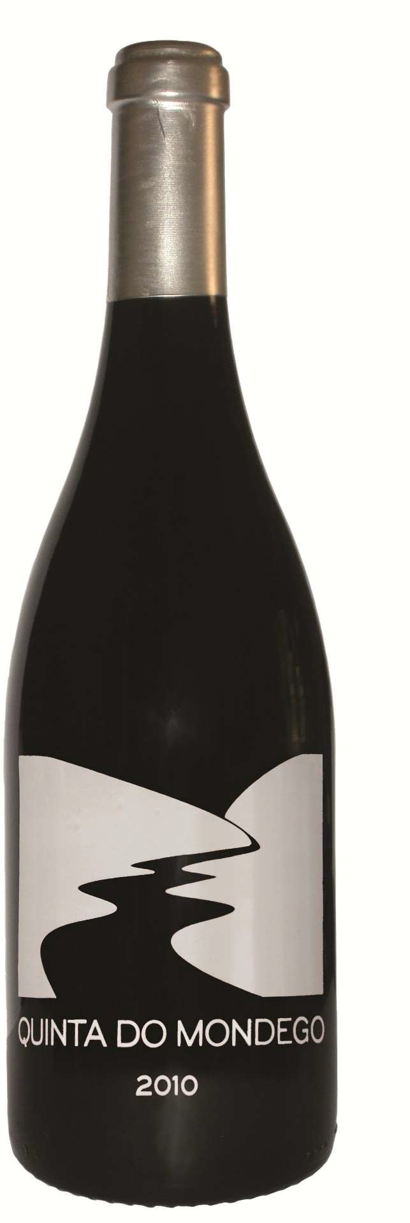Quinta do Mondego red
Jaen, Alfrocheiro, Tinta-Roriz, Touriga Nacional

Appellation: Nelas - Portugal
Alcohol: 11,0% by Vol.
Winery: Quinta Fontes da Cunha Winemaker: Joana Cunha

Winemaking:

Four grape varieties hand harvest and softly crushed together. Fermentation in small stainless steel at a controlled temperature of under 25ºC. Malolactic fermentation in to stainless steel vats. Aging in French oak wood casks for 12 months. Light filtration before bottling.

Tasting notes:

Beautiful red ruby color

Very fine and complex aroma, attractive and fresh with mint and fresh fruit

Flavors of ripe red and black fruits, together with good acidity. Well balanced and persistent. Elegant wine with fine quality tannins.

UPC 8-60033-22802-0 CASE CONTENT: 12x750ML CASE WEIGHT: 35 Lb.
CASE QTY per pallet LAYER: 15 (75 total)

T. 704 638-0004 | email: sales@ecovalleyimports.com | www.ecovalleyimports.com

