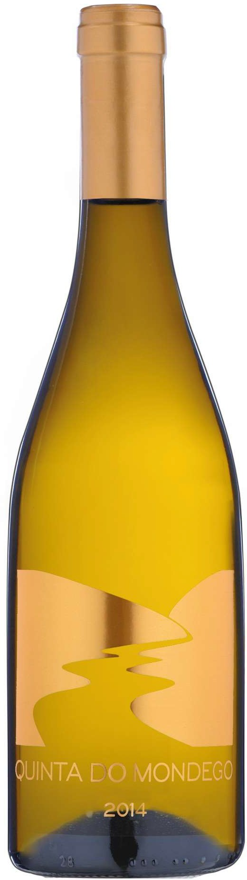Quinda do Mondego white
Encruzado, Gouveio

Appellation: Nelas - Portugal
Alcohol: 13,2% by Vol.
Winery: Quinta Fontes da Cunha Winemaker: Joana Cunha

Winemaking:

Soft stalk-removal and crushing. Gentle press and natural decantation at low temperatures for 24h. Fermentation of the Gouveio in stainless steel tanks at a controlled temperature and aging in the tank with lees stirring. Fermentation of the Encruzado in 500L french barrels (2nd year) and aging for 6 months with frequently battonage

Tasting notes:

Beautiful and attractive yellow citrus color. Attractive and fresh. Aromatic intense: lemon, mint, bread crumbs and mineral.

Well balanced, fresh and dry. The intensity of flavor dominated by lemon fruit, mint and minerals

Persistent finish

UPC
CASE CONTENT: 12x750ML CASE WEIGHT: 35 Lb.
CASE QTY per pallet LAYER: 15 (75 total)

T. 704 638-0004 | email: sales@ecovalleyimports.com | www.ecovalleyimports.com

