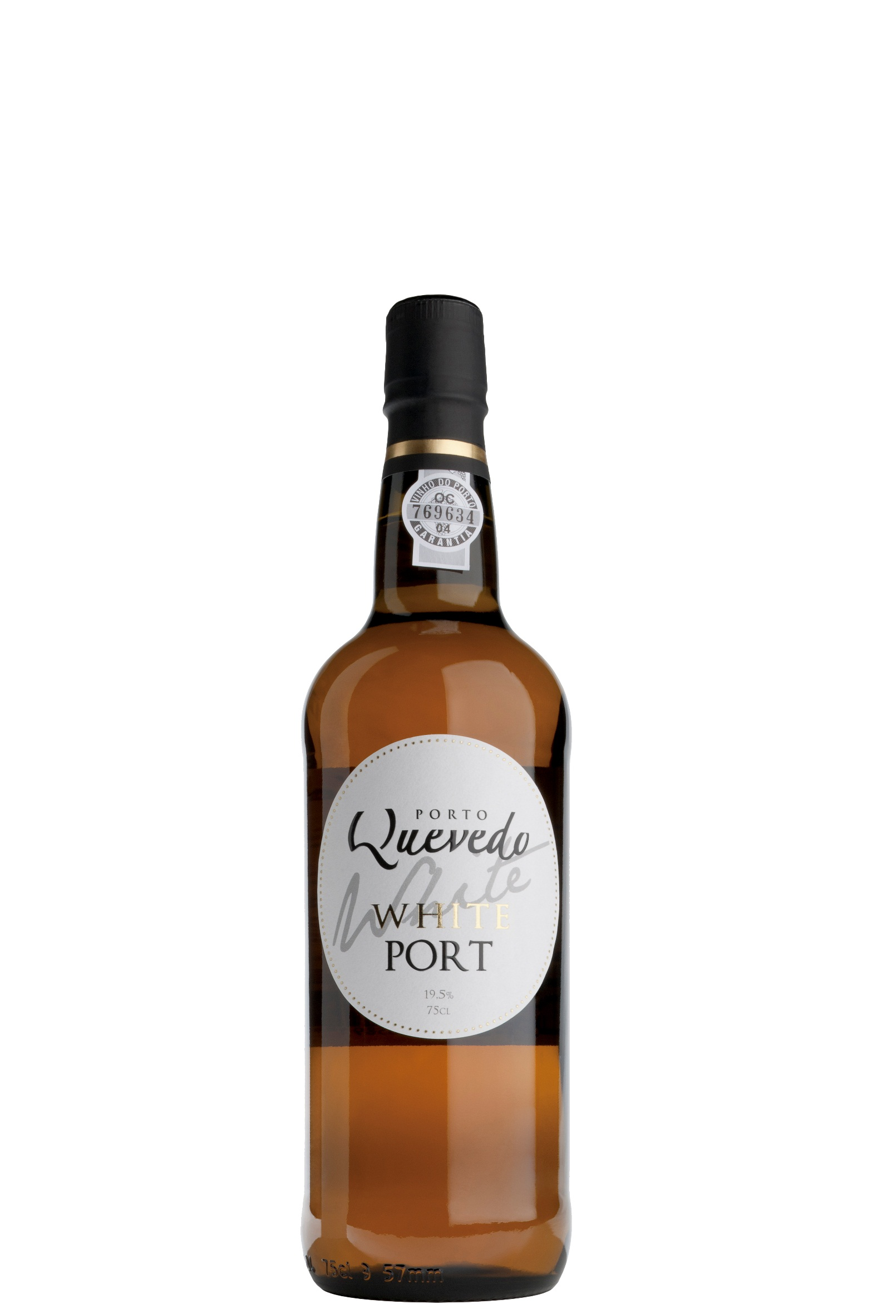

**Winemaking**:

Totally destemmed and crushed grapes, followed by a slow fermentation with skin contact. Fermentation temperature controlled up to 22ºC degrees. Soft filtration.

**Tasting notes:**

Light straw color. Sweet flavour that is similar to honey and jelly. White fruit nuances that resemble pear or apple jam. On the mouth it has a fruity intensity, with a great balance between acidity and sweetness. Full and structured finish

**UPC 5-60589-196104-8**

**CASE CONTENT: 12x750ML**

**CASE WEIGHT: 32 Lb.**

**CASE QTY per pallet LAYER: 18 (90 total)**

***Appellation****: Douro Valley - Portugal*

***Vintage:*** *Non-vintage*

***Alcohol:*** *19,5% by Vol.*

***Winery:*** *Quevedo*

***Winemaker:*** *Cláudia Quevedo*

Quevedo

**White Port**

T. 704 638-0004 | email: sales@ecovalleyimports.com | www.ecovalleyimports.com

