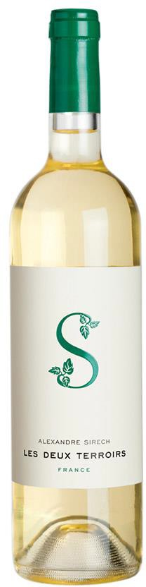

**Tasting notes:**

Golden hints on the robe. Intense and complex nose. Wide aromatic palette. Notes of exotic fruits (passion fruit, lychee), citruses (grapefruit, lemon and quince) and apricot brought by the Sauvignon, the Colombard and the Gros Manseng. On top of these fruity notes we can smell vegetal and floral touches (white flowers and boxwood). It’s full and structured on based on the freshness and roundness of the Ugni blanc and the Sauvignon. This harmony lingers in the mouth with very long-lasting aromas and tastes.

**Winemaking**:

Original blend of Sauvignon white from Bordeaux with aromatic grapes grown in beautiful terroirs of the Gers area (south-west of France). Once again, we stuck to our philosophy: freedom in the selection of grapes and in the blending process to propose the best wine to our consumers. Our Sauvignon white comes from cool and deep soils of La Sauve Majeure (heart of Bordeaux region), a place renowned for the quality of its white wines.

the Gers has the ideal terroir for aromatic grapes thanks to its heavy soils, its hills and its cold nights due to the proximity of the Pyrenean mountains.

**UPC 3760140140116**

**CASE CONTENT: 12x750ML**

**CASE WEIGHT: 36 Lb.**

***Appellation****: Bordeaux/Gers (South – West of France)*

***Vintage:*** *2016*

***Alcohol:*** *12,0% by Vol.*

***Winery:*** *Alexandre Sirech*

***Grape Blend:*** *Sauvignon-Colombard-Gros Manseng-Ugni Blanc.*

Alexandre Sirech

**Les Deux Terroirs –** **White.**

**Wine of France**

T. 704 638-0004 | email: sales@ecovalleyimports.com | www.ecovalleyimports.com

