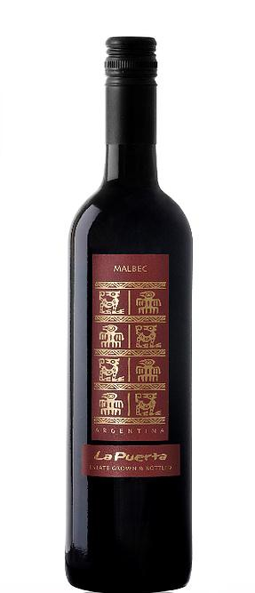La Puerta Clásico
Malbec

Appellation: Famatina Valley, La Rioja - Argentina Altitude: 1080 mts ASL
Vintage: Current Alcohol: 13,5% by Vol.
Winery: Valle de La Puerta

“Our vineyards lie on land that hundreds of years ago was inhabited by the indigenous people of La Rioja, The Diaguitas. To honor their heritage and culture we have adopted the Puma, that in their culture represents the supreme earthly being for its wisdom, strength and intelligence.” – Valle de La Puerta

Winemaking:

Fermentation: 6 to 7 days at 25ºC in temperature controlled stainless steel tanks with oak inner staves. Maceration period: 3 days in contact with is solids.
Malolactic fermentation: The wine is pumped to larger vats and kept at 18ºC. The wine is then clarified, cold stabilized, filtered and bottled.
Oak treatment: Inner staves used during fermentation, covering 20% of the surface area.

Tasting notes:

Deep red color. Aromas full of fruit with hints of violets that mingle with ripened plum and cherries, accompanying this wine's characteristically smooth and sweet tannins. This unique and delightful Malbec is well-balanced across the palate with a long and persistent finish

UPC 827599900920
CASE CONTENT: 12x750ML CASE WEIGHT: 37 Lb.
CASE QTY per pallet LAYER: 14 (70 total)

T. 704 638-0004 | email: sales@ecovalleyimports.com | www.ecovalleyimports.com

