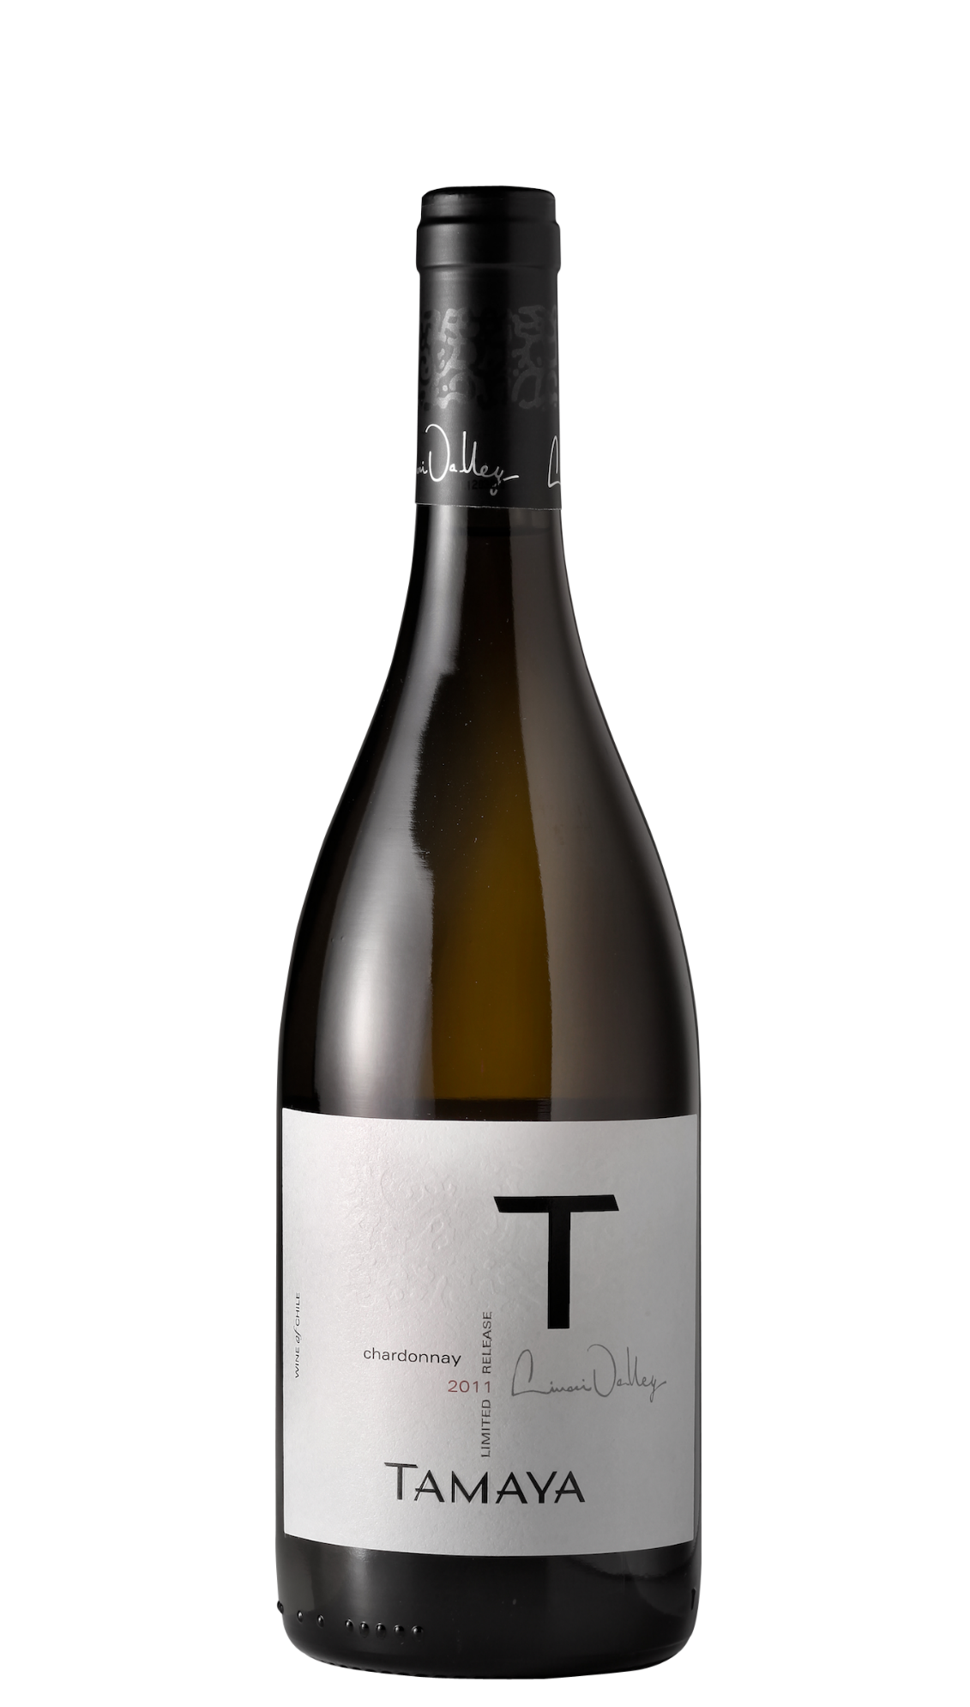

**Winemaking**: The Limarí Valley is unpolluted, luminous with clear skies and virgin soils of poor fertility and mineral characteristics. Spring and summer are free of rain. Cooling breezes blow from the Pacific Ocean which ensures the absence of frosts with ideal differences between day and night temperatures. All grapes are hand-picked and vineyard management is manually carried out with drip irrigation on all vines and minimal application of herbicides and pesticides due to fantastic pure conditions in the valley.

**Tasting notes:** A deep and dazzling gold yellow announces an elegant nose where citruses first appear with lime. Then come white fruits such as pears and golden apples with tangerine zests and green olive hints with a subtle and slightly smoky touch of English cream and vanilla. All this complex and also floral fan is enhanced by a lot of freshness and mineral chalk accents. The mouth starts immediately with a sensation of vibrant unctuosity. A lot of volume but no overweight at all thanks to its mineral and fresh structure. The density of the flesh, also revealed by its barrel aging is here unlighted by the nature of its soils and climate. The finish is long, tensed and powerful, expressing white fruits and white flowers with touches of honey and spicy fresh hazelnuts backed up by the mineral influences.

**UPC 8-54450-00041--3**

**CASE CONTENT: 6x750ML**

**CASE WEIGHT: 40 Lb.**

**CASE QTY per pallet LAYER: 22 (110 total)**

***Appellation****: Limarí Valley - Chile*

***Vintage:*** *2011*

***Alcohol:*** *13,5% by Vol.*

***Winery:*** *Viña Tamaya*

***Winemaker:*** *José Pablo Martin*

“T”

Carmenere

T. 704 638-0004 | email: sales@ecovalleyimports.com | www.ecovalleyimports.com

