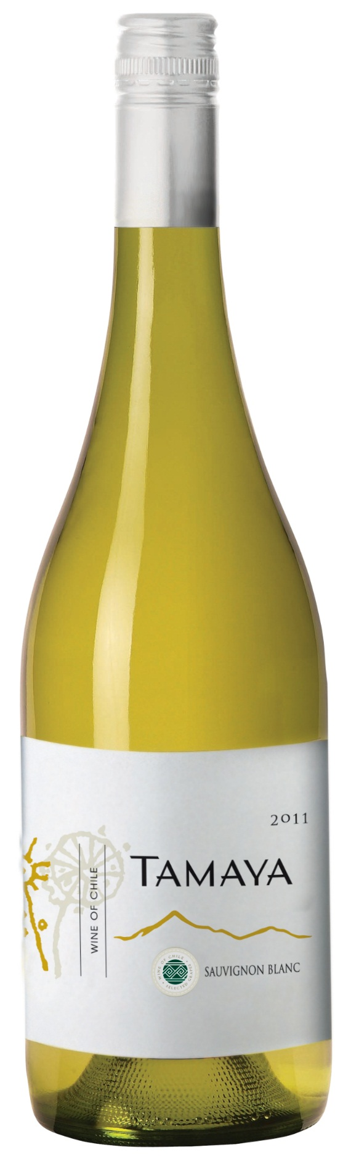

**Winemaking**: Hand-picked, destemmed and pressed in a pneumatic press. The juice remained on the skins for an average of 6 hours before being gently extracted at low pressure and statically decanted in stainless steel tanks until limpidity between 100 and 250 NTU was obtained. The clean must is then transferred to a fermentation tank and inoculated with selected yeasts. Alcoholic fermentation took place at 14°–16ºC (57°–61°F) and allowed to remain in the tanks with carbonic gas and daily lees stirring for an additional ten days. Then it was stabilized for proteins and tartaric acid, filtered, and bottled.

**Tasting notes:** Very pale yellow with brilliant slight green shades, this refreshing wine expresses herbal notes above broom flowers and box. The fruit is ripe but vibrant, with green apples, green pears and grapefruit, hints of green chilies and more exotic touches such as passion fruit. The mouth begins sharp and fresh and then develops a good volume with an excellent richness for the grape. The mineral column gives the structure, helped by a vibrant and juicy acidity but the wine is also all about fruitiness and preserves the complexity above nerves and austere greenness. The finish is made of flowers, white and exotic fruits enhanced by mineral accents.

**UPC 8-54450-00011-6**

**CASE CONTENT: 12x750ML**

**CASE WEIGHT: 32,5 Lb.**

**CASE QTY per pallet LAYER: 15 (75 total)**

***Appellation****: Limarí Valley - Chile*

***Vintage:*** *2014*

***Alcohol:*** *13,0% by Vol.*

***Winery:*** *Viña Tamaya*

***Winemaker:*** *José Pablo Martin*

Tamaya Estate

Sauvignon Blanc

T. 704 638-0004 | email: sales@ecovalleyimports.com | www.ecovalleyimports.com

