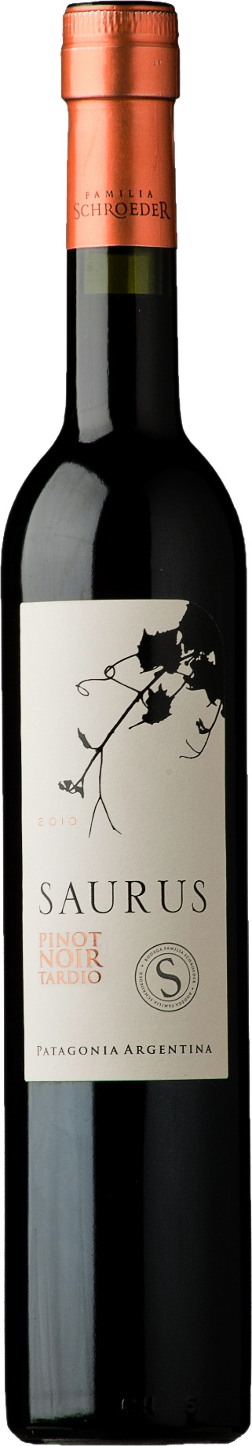

**Winemaking**:

Manual harvesting. When harvesting, the grape was dehydrated (as a raisin) and concentrated. Traditional (must, seeds and skin). Enzymes and bayanus yeasts were added for the alcoholic fermentation, realized in small open tanks at low temperatures and during 15 days with submerged cap. 7 days’ maceration to let the natural alcohol to extract glycerin and tannins. Aging in stainless steel tanks during 12 months at low temperatures. Natural clarification with cold and time.

**Tasting notes:**

The sight shows a typical soft red Pinot Noir color with orange hints due to the over ripening. In the glass is a heavy wine that creates persistent tears. To the nose, volatile and mineral aromas melt with some honey; ripen fruit, mandarin liquor and pollen scents. It is very complex. Different sensations appear once in the glass. Sweet and velvety mouth feeling. The natural acidity makes it fresh and persistent. Balanced wine with wood notes and sweet tannins provided by the contact with the seeds.

**UPC**

**CASE CONTENT: 6x750ML**

**CASE WEIGHT: 17 Lb.**

**CASE QTY per pallet LAYER: 44 (176 total)**

***Appellation****: Patagonia - Argentina*

***Vintage:*** *2011*

***Alcohol:*** *16,0% by Vol.*

***Winery:*** *Familia Schroeder*

***Winemaker:*** *Leonardo Puppato*

Saurus

**Pinot Noir Tardío**

T. 704 638-0004 | email: sales@ecovalleyimports.com | www.ecovalleyimports.com

