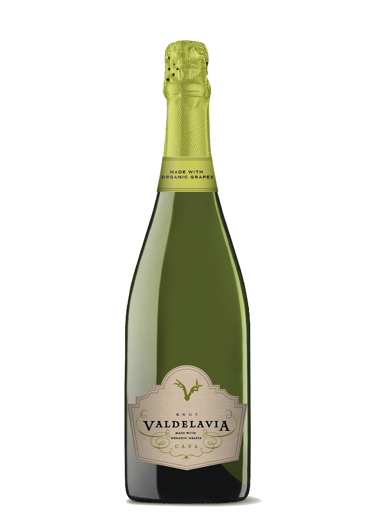

**Tasting notes:**

Light straw color with greenish tints. The carbonated content is bright and lively.

Its aromas are a mixture of fruit (melon, apple and banana) and the result of fermentation (toasted notes).

Harmonious and appetizing in the mouth, with a light touch of acidity. A rounded and elegant aftertaste. Classic fruity finish.

**Winemaking**:

Manual and mechanical harvest. Macabeo: 1st week of September. Xarel·lo: 2nd and 3rd weeks of September. Parellada: 1st week of October.

First fermentation in stainless steel tanks at a controlled temperature of 16ºC. 2nd in bottle using the Traditional Method. Aged 12 months in bottle.

**UPC 8-53646-00413-6**

**CASE CONTENT: 12x750ML**

**CASE WEIGHT: 42,5 Lb.**

**CASE QTY per pallet LAYER: 11 (55 total)**

***Appellation****: Vilobí de Penedes - Spain*

***Vintage:*** *NV*

***Alcohol:*** *12,5% by Vol.*

***Winery:*** *Vallformosa*

***Winemaker:*** *Xavier Pons*

***Certified:*** *Made from Organic Grapes (CCPAE)*

Valdelavia

Organic Cava Brut

T. 704 638-0004 | email: sales@ecovalleyimports.com | www.ecovalleyimports.com

