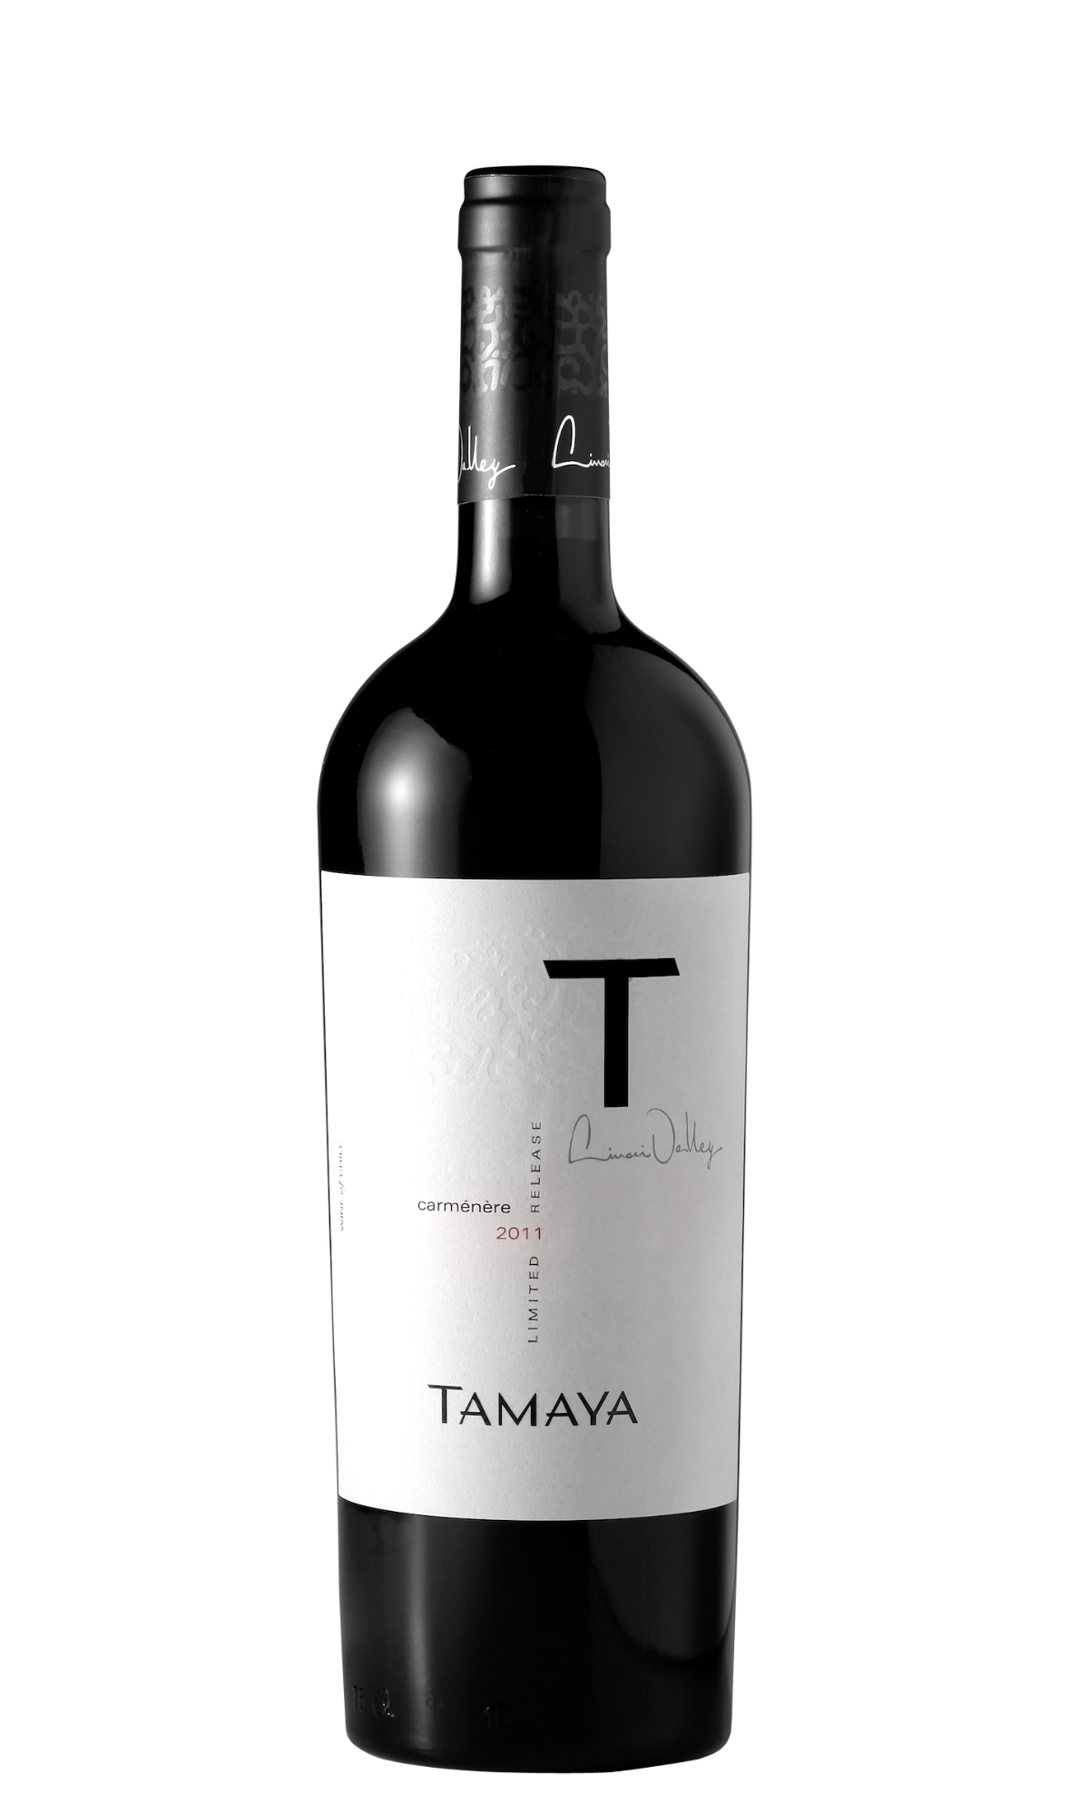

**Tasting notes:** Dense and deep purple, the T Carménère shows a great precision and elegance: touches of bread crust, cedar, sweet spices and soft licorice. More important however, the fruit is bright and fresh with cranberries, blackberries, cherries and plums. The background is quite mineral, displaying stony notes and brings depth to the typical notes of jammy red peppers, dry tomatoes and pink pepper. The mouth expresses at first a velvety voluptuousness thanks to silky and totally integrated tannins. This very designed frame structures a dense and juicy texture that carries all the aromatic complexity. The finish faithfully goes on and on, bright and lively, with ripe and spicy fruits, mineral notes and dried herbs.

**Winemaking**: The Limarí Valley is unpolluted, luminous with clear skies and virgin soils of poor fertility and mineral characteristics. Spring and summer are free of rain. Cooling breezes blow from the Pacific Ocean which ensures the absence of frosts with ideal differences between day and night temperatures. All grapes are hand-picked and vineyard management is manually carried out with drip irrigation on all vines and minimal application of herbicides and pesticides due to fantastic pure conditions in the valley.

**UPC 8-54450-00038-3**

**CASE CONTENT: 6x750ML**

**CASE WEIGHT: 40 Lb.**

**CASE QTY per pallet LAYER: 22 (110 total)**

***Appellation****: Limarí Valley – Chile*

***Vintage:*** *2011*

***Alcohol:*** *13,5% by Vol.*

***Winery:*** *Viña Tamaya*

***Winemaker:*** *José Pablo Martin*

“T”

Carmenere

T. 704 638-0004 | email: sales@ecovalleyimports.com | www.ecovalleyimports.com

