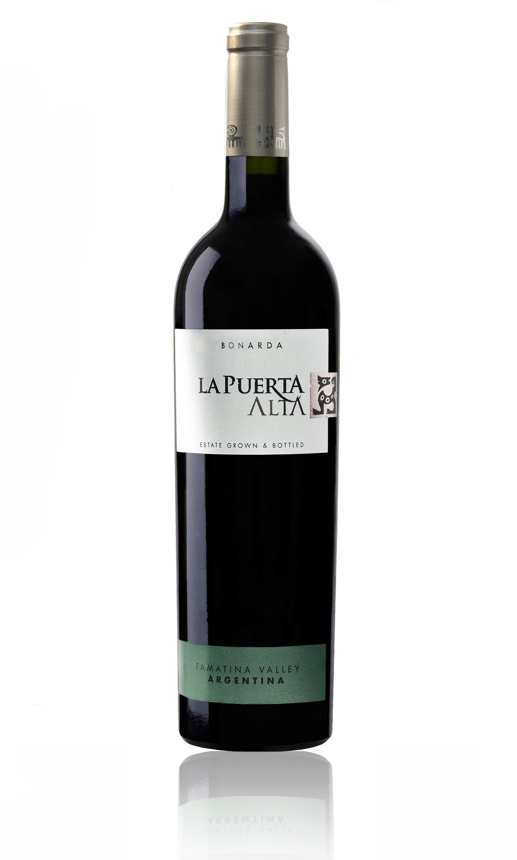

**Tasting notes:**

The wine is a rich deep red in color, whilst the nose shows vibrant plum with flower nuances. There is an abundance of juicy fruit on the palate with perfectly integrated oak and fine tannins with each element impeccably balanced.

**Winemaking**:

Only the best fruit goes into La Puerta Alta, out estate grown and bottles wines. The grapes are hand-picked from drip irrigated vines which are hand pruned and canopy-managed for optimum flavor ripeness.

Once the wines are produced the best reds are carefully selected for the Alta range and kept in separate tanks until both primary and secondary fermentation is complete. Then they are blended with our Reserva wines, aged in French and American oak barrels for 3 months.

**UPC 8-73250-00877-1**

**CASE CONTENT: 12x750ML**

**CASE WEIGHT: 38 Lb.**

**CASE QTY per pallet LAYER: 14 (70 total)**

***Appellation****: Famatina Valley, La Rioja - Argentina*

***Altitude:*** *1000 mts ASL*

***Vintage:*** *2013*

***Alcohol:*** *13,5% by Vol.*

***Winery:*** *Valle de La Puerta*

***Winemaker:*** *Javier Collovati*

La Puerta Alta

T. 704 638-0004 | email: sales@ecovalleyimports.com | www.ecovalleyimports.com

