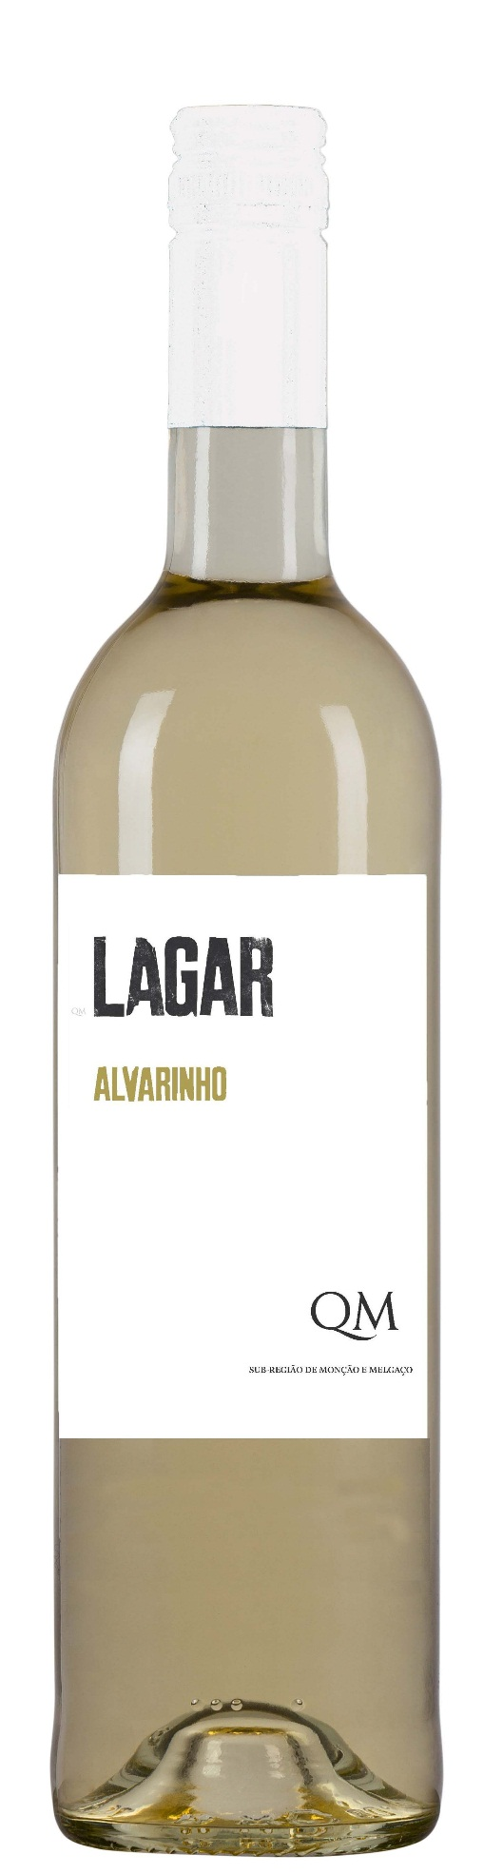

**Tasting notes:**

Limpid and citrine color, tropical fruits aromas and light floral notes. In the mouth, the volume and balance of all components stand out, as well a lively and refreshing acidity, full body and long finish.

**Winemaking**:

Soft pressing and decanting for 12 to 36 hours under controlled temperatures 12ºC – 16ºC. Fermentation till 15 days under controlled temperatures 16ºC – 18ºC.

Maturation: In stainless steel vats under controlled temperatures and regular movement of the lees during 2 months.

**UPC 8-55365-00522-7**

**CASE CONTENT: 12x750ML**

**CASE WEIGHT: 31 Lb.**

**CASE QTY per pallet LAYER: 15 (75 total)**

***Appellation****: Alvaredo DOC Vinhos Verdes - Portugal*

***Vintage:*** *2013*

***Alcohol:*** *12,5% by Vol.*

***Winery:*** *Quintas de Melgaço*

***Winemaker:*** *Jorge Sousa Pinto and Virgínia Raínho*

Lagar

**Alvarinho**

T. 704 638-0004 | email: sales@ecovalleyimports.com | www.ecovalleyimports.com

