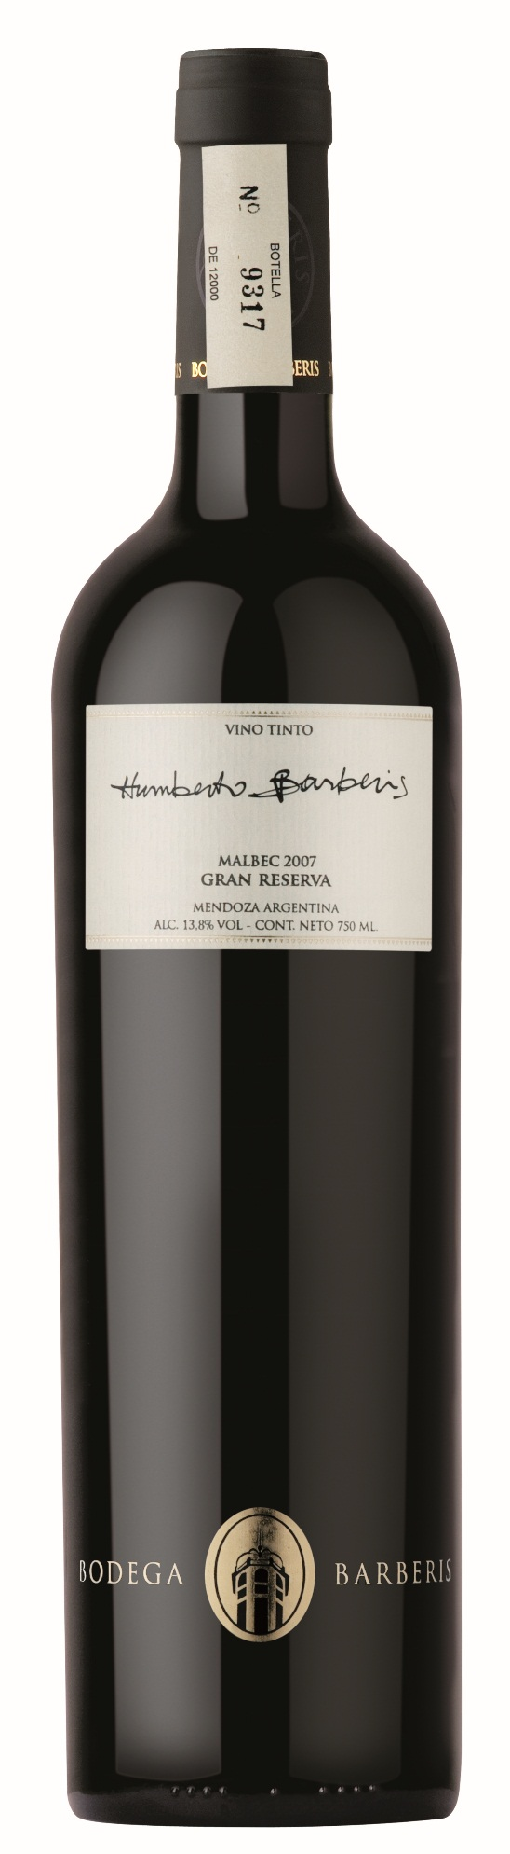

**Tasting notes:**

Deep bright red color with aromas of plums and red berries, mixed with vanilla, chocolate and snuff. Very round, long lasting and balanced on the palate, with an elegant and complex finish.

***Appellation****: Mendoza - Argentina*

***Vintage:*** *2010*

***Alcohol:*** *14,0% by Vol.*

***Winery:*** *Bodega Barberis*

***Winemaker:*** *Mónica Calderón*

**UPC 8-36344-00076-1**

**CASE CONTENT: 6x750ML**

**CASE WEIGHT: 20 Lb.**

**CASE QTY per pallet LAYER: 30 (150 total)**

Humberto Barberis Gran Reserva

**Malbec**

**Winemaking**:

Manual selection of clusters, pre-fermentation maceration in cold for five days at 10 °C. Selected yeasts. Alcoholic fermentation for 14 days with controlled temperatures between 27-30 °C. Daily remontage and post-fermentation maceration for 25 days.

T. 704 638-0004 | email: sales@ecovalleyimports.com | www.ecovalleyimports.com

