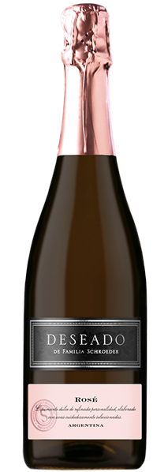

**Tasting notes:**

Very attractive pink sparkling wine with fine bubbles. Complex nose with a combination of red fruits, flowers and quince. Sweet, fruity palate with good acidity and volume.

***Appellation****: Patagonia - Argentina*

***Vintage:*** *NV*

***Alcohol:*** *9,5% by Vol.*

***Winery:*** *Familia Schroeder*

***Winemaker:*** *Leonardo Puppato*

**UPC 827599900920**

**CASE CONTENT: 6x750ML**

**CASE WEIGHT: 23,5 Lb.**

**CASE QTY per pallet LAYER: 22 (110 total)**

**Winemaking**:

Must extraction with pneumatic press. 48 hours after, removal of the lees and addition of enzymes. Filtration. Fermentation in tanks with selected yeasts.

Maintenance of temperatures between 14 and 15°C for 15 days in order to reach a 6 atmospheres pressure. Stop of the fermentation with cold, leaving the natural sugar of the must in 70 G/L. Result: sparkling from first fermentation. Storing above lees during 1.5 months. Bottling with isobarometric line and 3-month store

Deseado Rosé

**Torrontes - Malbec**

T. 704 638-0004 | email: sales@ecovalleyimports.com | www.ecovalleyimports.com

