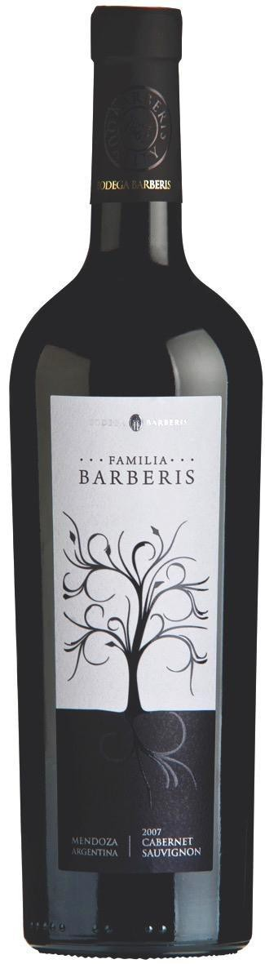Familia Barberis
Cabernet Sauvignon

Appellation: Mendoza – Argentina
Alcohol: 13,5% by Vol. Winery: Bodega Barberis

“The family tradition of Barberis Winery began around the year 1895 in Piedmont, Italy. “Like many Europeans, our forefathers embarked for America in search of a dream. After many years of hard work our dreams came true and, in 1965., the winery was inaugurated” – Adrián Barberis

Winemaking:

The grapes come from vineyards located in the main wine regions of Mendoza, where the best agronomic methods are used to obtain fruit of excellent quality.

Manual selection of clusters, pre-fermentation maceration in cold for four days at 10 °C. Selected yeasts, alcoholic fermentation for 12 days with controlled temperatures between 27-30 °C. Daily pump-overs and post-fermentation maceration for 20 days.

Tasting notes:

Garnet red color with aromas of ripe red fruits, strawberries and peppers with notes of toast coming from its oak ageing.
It is well balanced across the palate and has a long lasting finish.

UPC 827599900920
CASE CONTENT: 12x750ML CASE WEIGHT: 37 Lb.
CASE QTY per pallet LAYER: 14 (70 total)

T. 704 638-0004 | email: sales@ecovalleyimports.com | www.ecovalleyimports.com

