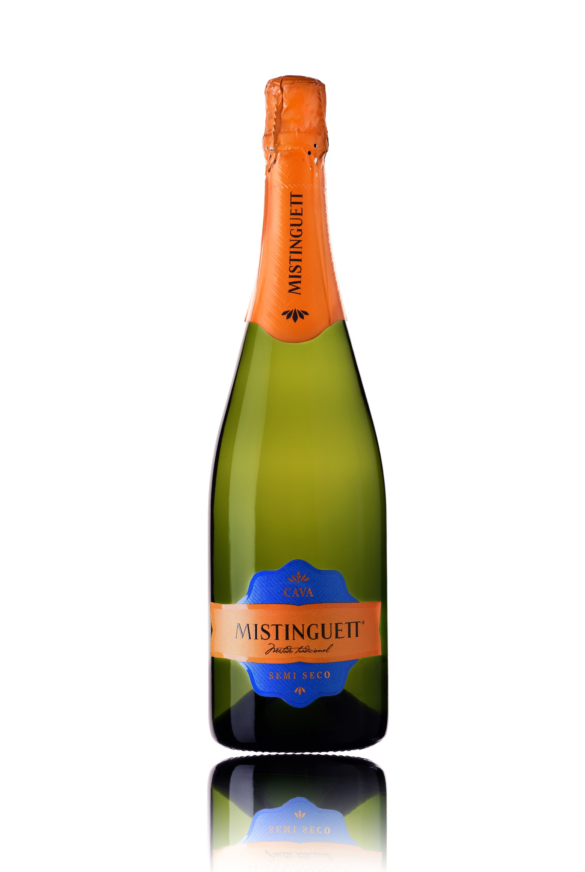

**Winemaking**:

Manual and mechanical harvest. Viura: beginning of September. Xarel-lo: 2nd and 3rd week of September. Parellada: 1st half of October.

First fermentation in stainless steel tanks at a controlled temperature of 16ºC. 2nd in bottle using the Traditional Method. Aged 12 months in bottle.

**Tasting notes:**

Straw yellow with golden reflections. Fine, persistent bubbles. Light foam.

Aroma of fresh fruit, jovial, full and rounded. In the nose aromas fruit are most prominent (recalling vine-flower, pineapple, apple and peach).

In the mouth it is very well balanced, harmonious and subtle. A long and pleasant finish with body.

**UPC 8-53646-00432-7**

**CASE CONTENT: 12x750ML**

**CASE WEIGHT: 42,5 Lb.**

**CASE QTY per pallet LAYER: 11 (55 total)**

***Appellation****: Vilobí de Penedes - Spain*

***Vintage:*** *NV*

***Alcohol:*** *12,5% by Vol.*

***Winery:*** *Vallformosa*

***Winemaker:*** *Xavier Pons*

Mistinguett

Cava Semi-Sec

T. 704 638-0004 | email: sales@ecovalleyimports.com | www.ecovalleyimports.com

