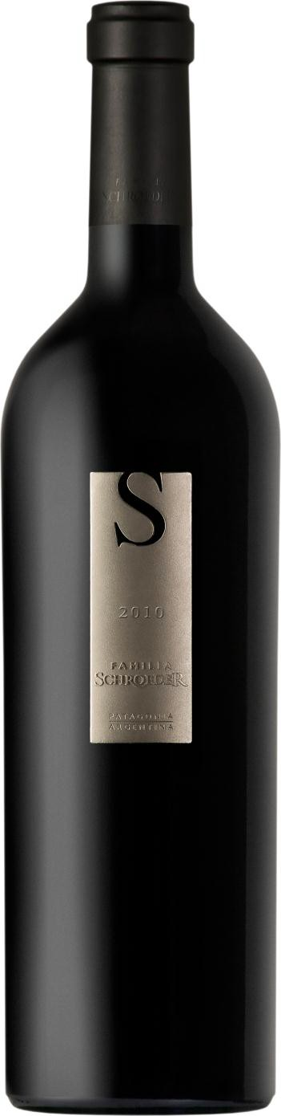
Familia Schroeder ‘S’ Series
Malbec - Pinot Noir

Appellation: Patagonia - Argentina
Alcohol: 14,5% by Vol. Winery: Familia Schroeder

“In 1999, during the construction of our winery, fossils of an Aeolosaurus were found at the site. The name comes from the Greek “Aeolo”, which means wind and “Saurus”, which means lizard.
Such an important discovery inspired us to name our first line of wines Saurus!” – Familia Schroeder

Winemaking:

Thirteen-day alcoholic fermentation at 25ºC in stainless steel tanks with selected yeasts.
Seven day second-maceration with submersible cup. Malolactic fermentation in new French oak casks after the cut is made.
100% of this wine was aged 14 months in new
French oak casks.

Tasting notes:

Deep bright red color with some violet hints. This blend features a complex nose. Ripe red fruit aromas such as plums, sour berries and cassis, gently combined with floral and spicy nuances. Delicate vanilla and chocolate tones were developed during the long aging in French oak barrels. Sophisticated mouth-feel and remarkable elegance. The wine expands on the palate letting the flavors linger persistently.

UPC 827599900920
CASE CONTENT: 12x750ML CASE WEIGHT: 37 Lb.
CASE QTY per pallet LAYER: 14 (70 total)

T. 704 638-0004 | email: sales@ecovalleyimports.com | www.ecovalleyimports.com

