
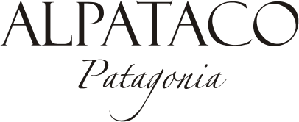
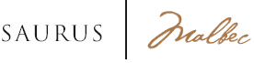

HARVEST DATE
First half of March

VARIETAL COMPOSITION
100% Malbec

YIELD
11,500 Kg. / hectare

HARVEST METHOD AND SELECTION
Hand-picked and then manually selected on vibratory table

ALCOHOLIC FERMENTATION
With selected enzymes and yeasts in stainless steel tanks during 12 days

MACERATION TIME
Two days at low temperatures with CO_{2.} A second maceration is done after the alcoholic fermentation, during three days with submerged cap

MALOLACTIC FERMENTATION
Spontaneous fermentation in stainless steel tanks for 100% of the wine

AGING
Kept on the lees in stainless steel tanks with periodical stirring until final stabilization and bottling.

TECHNICAL INFORMATION – HARVEST 2019
Alcohol: 13.5 % VOL
Total acidity: 5.80 G/L
PH: 3.57
Residual sugar: 3.17 G/L

PRODUCTION
156.000 bottles
TASTING NOTES
Intense deep red with purple accents.
Distinctive ripe red fruit aromas like plums and cherries and delicate violet nuances.
The contact with the lees leave a reminiscence of dried fruits.
Soft and full mouth-feel. Remarkably fresh and appealing.

WINEMAKER
Lic. Leonardo Puppato



