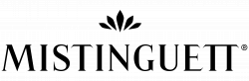

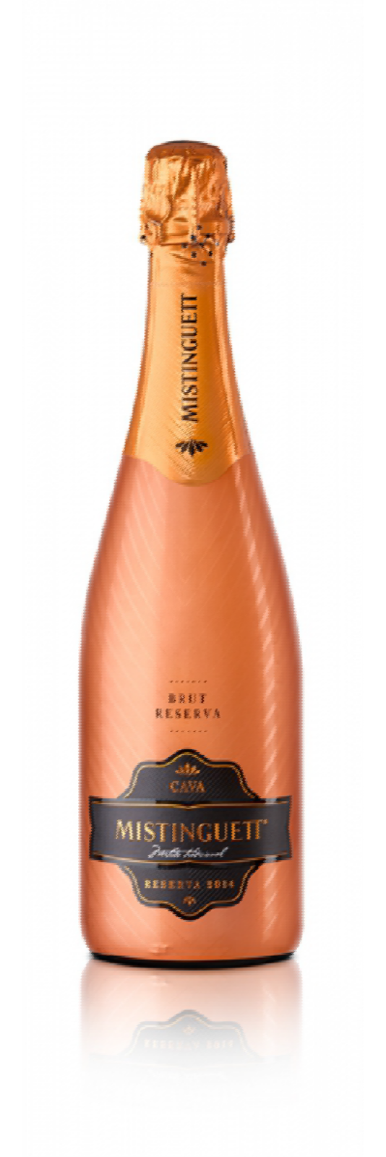
Mistinguett | Brut Reserva

VINTAGE: 2015
WINE TYPE: Cava Brut Reserva
VARIETIES: Macabeo, Xarel lo and Parellada D.O.: Cava
VINEYARD LOCATION: In the Cava region, situated in the Alt Penedès

PRODUCTION

HARVEST: Manual and mechanical. Macabeo: 1st week of September. Xarel lo: 2nd and 3rd week of September. Parellada: 1st week of October.
FERMENTATION: 1st fermentation in stainless steel thermo-regulated vats at a temperature of 16ºC. 2nd fermentation in bottle using Traditional Method.
AGEING: Ageing average period of 18 months in bottle. BOTTLE TYPE: Standard green cava, of 750 ml.

TASTING NOTE

IN APPEARANCE: Yellow, pale, with greenish and grayish trim.
ON THE NOSE: Aromas of white fruit mixed with subtle notes of pastry parenting, giving a fresh and warm at the same time showing its complexity nose.
ON THE PALATE: On palate, soft yet structured, with fine and elegant bubbles. We found the notes a little more ripe fruit, but with a lively acidity that gives us start in the aftertaste, with hints of pastry.

SERVING RECOMMENDATIONS

It is an elegant cava , with a fine and persistent bubble. To take any food and even dessert. Suitable for processed foods, such as meat or fish. Serve between 5 and 6 C.

TECHNICAL DETAILS

ALCOHOL CONTENT: 11,5 % Vol. RESIDUAL SUGAR: 9,8 g/L TOTAL ACIDITY (H2SO4): 3,90 g/L pH: 3.01

AWARDS
GOLDEN - 2017 Berliner Wein Trophy 2017, Berlin - Germany
SILVER - 2017 International Wine & Spirit Competition, London - United Kingdom COMMENDED MEDAL – 2017 International Wine Challenge, London - United Kingdom

