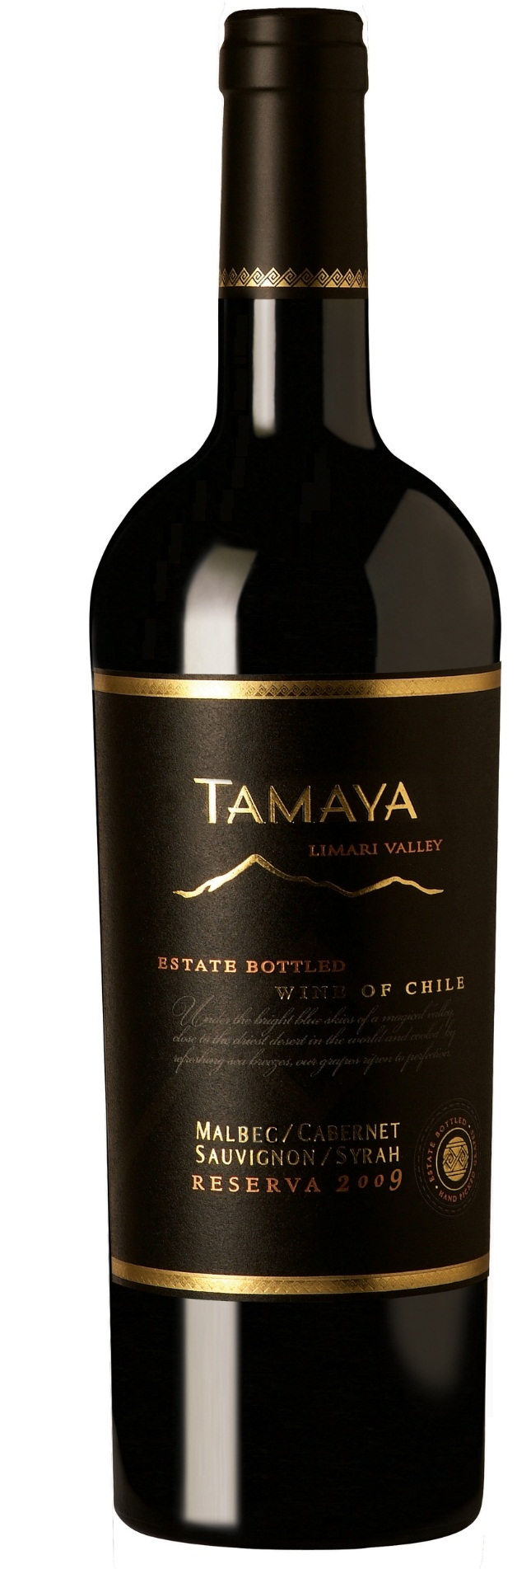

**Winemaking**: Hand-picked, destemmed, lightly crushed, and deposited in stainless steel fermentation tanks. Alter a 3-day pre-fermentation cold soak, the must was inoculated with selected yeasts. Fermentation followed at 262 'ba-282 'baC (792'ba-82F), with aerated pump overs of l.5 times the tank volume in the beginning and reduced to half the volume at the end of the fermentation process. Upon completion of the alcoholic fermentation, the wine was left on its skins for an additional week to gain greater structure and character. The wine was then rocked off its skins, which were pressed for a second time. Part of the free run wine and some of the press wine were oak aged for 10 months. The final blend included half oak-aged wine and half tank wine. Cold stabilized, filtered, and bottled.

**Tasting notes:** Dense, deep purplish in color, with a very expressive nose that features ripe and jammy wild berries, redcurrants, strawberries and plums. Meaty tones add personality to a background made of dried leaves, spicy flowers and wet underbrush. Mineral and balsamic notes underline the overall view. The palate starts recreating the nose atmosphere through a juicy, fresh and smooth texture. The spicy frame of fine tannins brings deepness and relieves, and leads to a lively and very expressive finish lull of wild berries, flowers, spices and incenses hints.

**UPC 8-54450-00044-4**

**CASE CONTENT: 12x750ML**

**CASE WEIGHT: 35 Lb.**

**CASE QTY per pallet LAYER: 14 (70 total)**

***Appellation****: Limarí Valley - Chile*

***Vintage:*** *2011 - 2013*

***Alcohol:*** *13,5% by Vol.*

***Winery:*** *Viña Tamaya*

***Winemaker:*** *José Pablo Martin*

Tamaya Reserva

Malbec – Cabernet Sauvignon - Syrah

T. 704 638-0004 | email: sales@ecovalleyimports.com | www.ecovalleyimports.com

