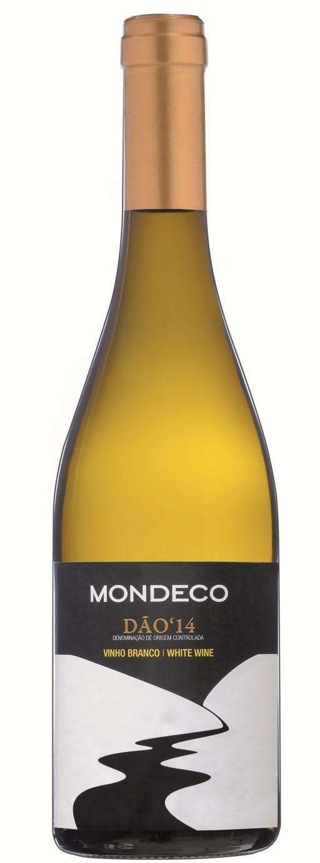Mondeco White Dao Encruzado – Gouveio

Appellation: Nelas - Portugal
Alcohol: 13,0% by Vol
.
Winery: Quinta Fontes da Cunh
a

Mondeco is the river that runs with pure crystalline water across Quinta Fontes da Cunha vineyards and meets the ocean not far away from their small boutique family winery.
Jonana Cunha, the winemaker, creates international style wines using indigenous grape varieties.

Winemaking:

Soft stalk -removal and crushing. Both varieties are gently pressed together and naturally decanted at low temperatures for 24 hours.
Fermentation of 60% of the grape blend occurs in stainless steel vats at low temperature and 40% is fermented in 500L French oak barrels (2nd use) for at least 6 months with frequent battonage.

Tasting notes:

Beautiful and attractive yellow citrus color; attractive and fresh. Aromatically intense with white and fresh fruit and mineral components.
Well balanced, fresh and dry. The intensity of flavor is dominated by lemons and fresh fruit. Persistent finish.
Goes well with fresh salads, fish and seafood, pasta and risotto.

UPC 827599900920
CASE CONTENT: 12x750ML CASE WEIGHT: 37 Lb.
CASE QTY per pallet LAYER: 14 (70 total)

T. 704 638-0004 | email: sales@ecovalleyimports.com | www.ecovalleyimports.com

