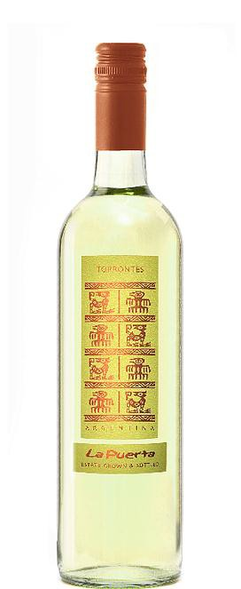La Puerta Clásico
Torrontés

Appellation: Famatina Valley, La Rioja, Argentina
Altitude: 1040 mts ASL
Vintage: Current Alcohol: 13,5% by Vol.
Winery: Valle de La Puerta

“Our vineyards lie on land that hundreds of years ago was inhabited by the indigenous people of La Rioja, The Diaguitas. To honor their heritage and culture we have adopted the Puma, that in their culture represents the supreme earthly being for its wisdom, strength and intelligence.” – Valle de La Puerta

Winemaking:

After pressing the fruit, the resulting juice is cooled and pumped to a holding tank for “cold settling”.
The chilled juice is held at a temperature too low for fermentation to occur so that the grape solids can settle out and the fermentation proceed on clean juice.
The juice is then “seeded” with a cultured yeast and slowly fermented under temperature controlled conditions in stainless steel tanks for up to a month.

Tasting notes:

Powerful honeysuckle and other floral aromas are characteristic of this unique wine. It has an elegant pale yellow color with hints of green, while on the palate crisp acidity provides cleanliness and works as a platform for the citrus flavors. Finishes clean and refreshing, with more floral hints.

UPC 827599900920
CASE CONTENT: 12x750ML CASE WEIGHT: 37 Lb.
CASE QTY per pallet LAYER: 14 (70 total)

T. 704 638-0004 | email: sales@ecovalleyimports.com | www.ecovalleyimports.com

