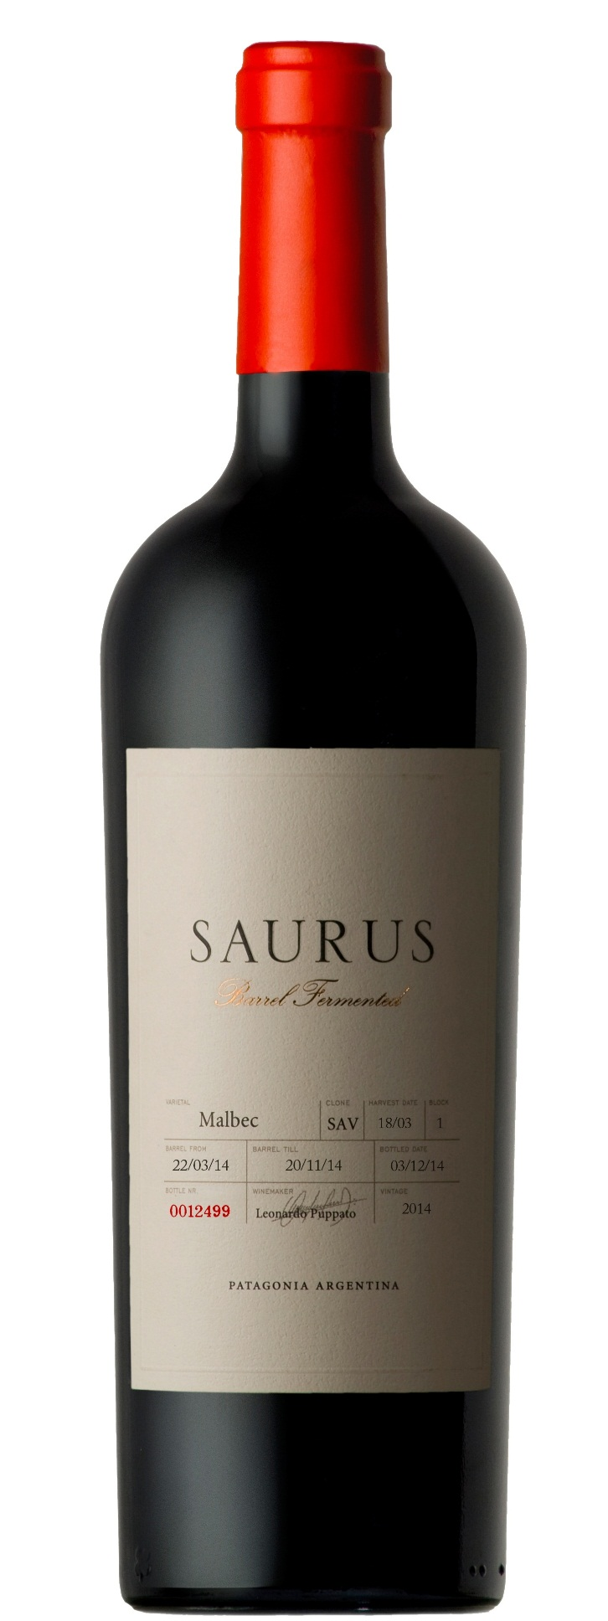

**Winemaking**:

Picked by hand and kept in cold chamber at 8 °C until selected in vibratory table. Stainless steel tank maceration with whole grain, five days at low temperatures before fermentation with added enzymes and dry ice pellets. Five days’ alcoholic fermentation in contact with skins in tank, then racked in oak barrels for further alcoholic fermentation. Malolactic fermentation starts by re-racking in new barrels. Eight-month aging, 60% in American oak barrels and 40% in French barrels. The toasting of the barrels was exclusively made for this winery´s use.

**Tasting notes:**

The eyes meet red colors with vibrant violet flashes. Red fruits aromas, plums and cherries combined with flowers such as Violets. The oak fermentation provides an enduring structure and delicate notes of mocha, vanilla and chocolate to the palate, resulting in a complex and elegant wine.

**UPC 8-77497-00037-6**

**CASE CONTENT: 6x750ML**

**CASE WEIGHT: 24 Lb.**

**CASE QTY per pallet LAYER: 11 (55 total)**

***Appellation****: Patagonia - Argentina*

***Vintage:*** *Current*

***Alcohol:*** *14,0% by Vol.*

***Winery:*** *Familia Schroeder*

***Winemaker:*** *Leonardo Puppato*

Saurus Barrel Fermented

**Malbec**

T. 704 638-0004 | email: sales@ecovalleyimports.com | www.ecovalleyimports.com

