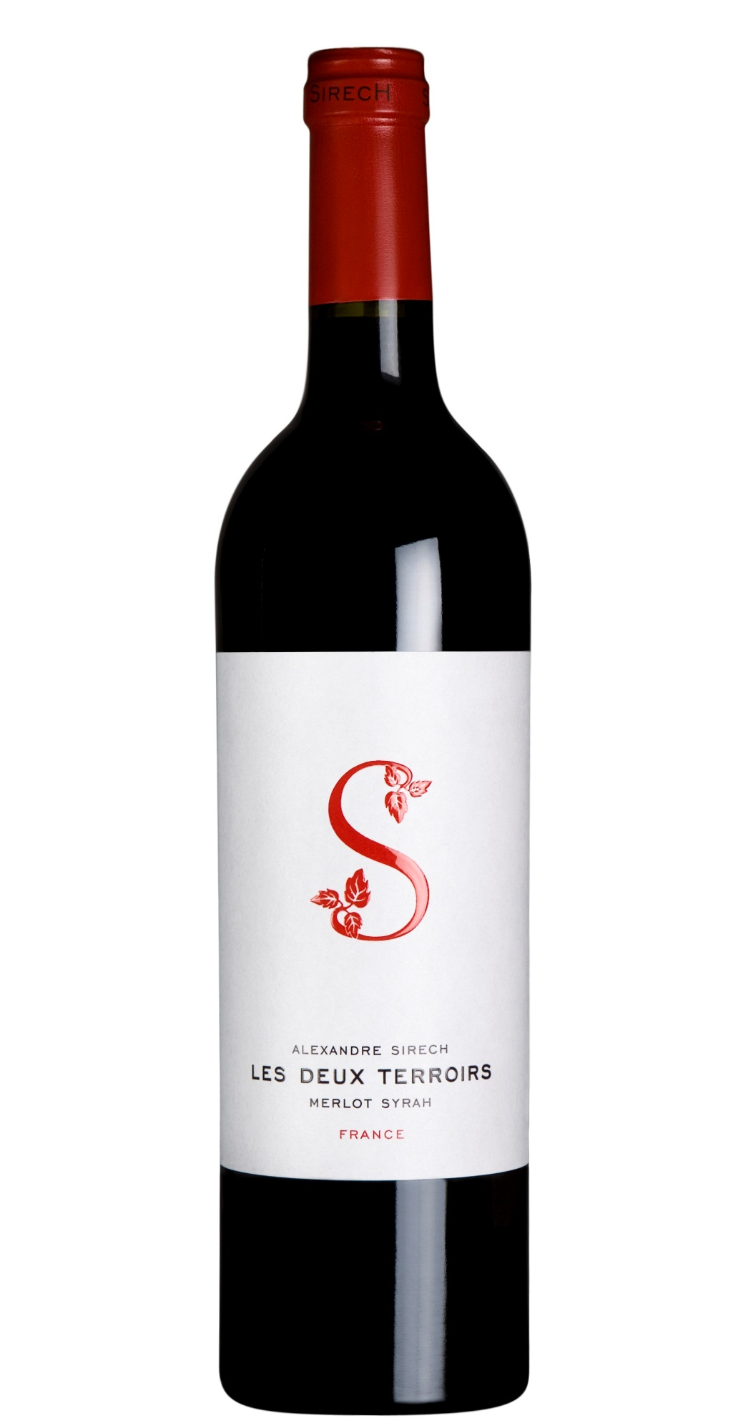

**Tasting notes:**

Round, smooth and balanced, "Les Deux Terroirs" is in every sense a fine wine. Its aromas of red fruits are accentuated by hints of spice, cocoa and mocha. It offers a complex bouquet of aromas, which is the result of blending wines from different grapes varietals, regions and vintages.

**Winemaking**:

Bordeaux is the home of merlot. It is in the Bordelais area around Libourne that it is at its best. It is there that we source our supplies, from vineyards rigorously selected at the peak of their respective appellation. Merlot brings fruit and elegance but needs to be associated with a sturdier wine. We, however, have chosen to use syrah to play this role. It provides structure but also adds sunny exoticism together with fine notes of cocoa, mocha and a touch of spice without in any way detracting from the fruit and elegance of the merlot. Given that syrah is not authorized by the appellation rules applied in Bordeaux, we source it from the southeast of France where it is best. We take it straight from a top estate where it has already been aged in French-oak casks.

***Appellation****: Bordeaux,and South East of France*

***Vintage:*** *2013*

***Alcohol:*** *14,0% by Vol.*

***Winery:*** *Alexandre Sirech*

***Winemaker:*** *Jean-Philippe Janoueix*

**UPC 7-60140-14001-7**

**CASE CONTENT: 6x750ML**

**CASE WEIGHT: 36,4 Lb.**

**CASE QTY per pallet LAYER: 28 (140 total)**

Les Deux Terroirs

**Merlot - Syrah**

T. 704 638-0004 | email: sales@ecovalleyimports.com | www.ecovalleyimports.com

