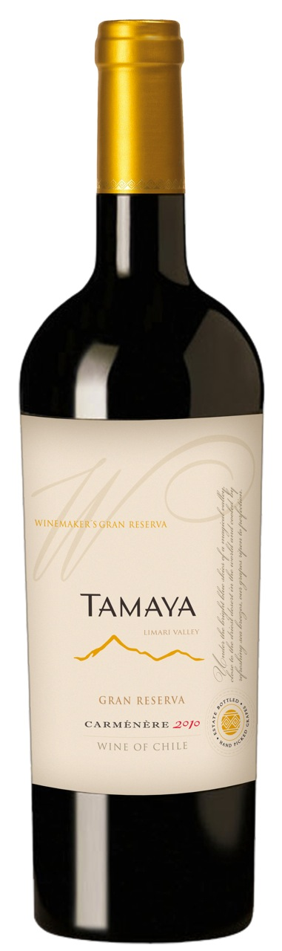

**Tasting notes:** Deep and intense, this wine shows a brilliant purple and introduces itself with a fresh and characteristic nose. Wild berries, plums, blackberries, dried tomatoes and roasted red peppers. The rising complexity also gives wet earth and stones, graffito, fresh liquorice black pepper and smooth spices. The mouth initiates with juicy sensations and all the freshness of the fruit. Well surrounded by small and fine tannins helping in increasing density, the texture gets intensity and slowly leads to a smooth and vibrant finish of impressive length made of spices, underbrush and wild berries enhanced by mineral hints, liquorice and tobacco.

**Winemaking**: Harvested by hand, destemmed and gently crushed and sent to a stainless steel cat for fermentation where selected yeasts were added. During the fermentation process the must was macerated with aerated recycling gradually moving the liquid from the bottom to the top of the vat 1.5 times until the fermentation process reached half the alcoholic volume. The alcoholic fermentation was finalized by macerating the wine with the grape skins for one more week. The wine was then separated from the grape skins which were then pressed to yield a second fraction of wine. After that, the wine was aged in French Oak Barrels. Finally, the best barrels were selected to create the blend, then filtered and bottled.

**UPC 8-54450-00038-3**

**CASE CONTENT: 12x750ML**

**CASE WEIGHT: 40 Lb.**

**CASE QTY per pallet LAYER: 11 (55 total)**

***Appellation****: Limarí Valley - Chile*

***Vintage:*** *2011*

***Alcohol:*** *13,5% by Vol.*

***Winery:*** *Viña Tamaya*

***Winemaker:*** *José Pablo Martin*

Tamaya Winemakers Gran Reserva

Carmenere

T. 704 638-0004 | email: sales@ecovalleyimports.com | www.ecovalleyimports.com

