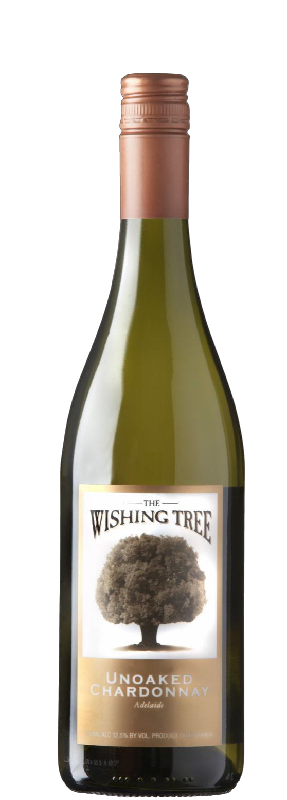The Wishing Tree
Chardonnay

Appellation: Adelaide - Australia
Alcohol: 13,0% by Vol.
Winery: Nick Haselgrove Wines

“The name The Wishing Tree comes from childhood days. As children, we were convinced by our parents that if we made a wish under this beautiful old Oak tree, it would become true.
As I recall it did work on occasion!” - Nick Haselgrove

Winemaking:

All fruit sourced from established vineyards in the Greater Appellation of "Adelaide” which incorporates the Appellations of Barossa & Clare Valley's, McLaren Vale & the Adelaide Hills.

The fruit for this un-oaked Chardonnay is sourced from higher elevation vineyards.
The diverse fruit characters from each vineyard combine to produce a fresh & complex wine.
Fermented & cold stabilized in steel tanks, sur lees.

Tasting notes:

Bright and fresh with green color and light straw tint. Youthful. An aromatic style with light tropical fruit and light peach, melon with a green apple edge. Medium palate weight with bright green fruits and a citric, lime juice nuance. Subtle texture on the palate adds a deliciousness and a fresh clean finish.

UPC 827599900920
CASE CONTENT: 12x750ML CASE WEIGHT: 37 Lb.
CASE QTY per pallet LAYER: 14 (70 total)

T. 704 638-0004 | email: sales@ecovalleyimports.com | www.ecovalleyimports.com

