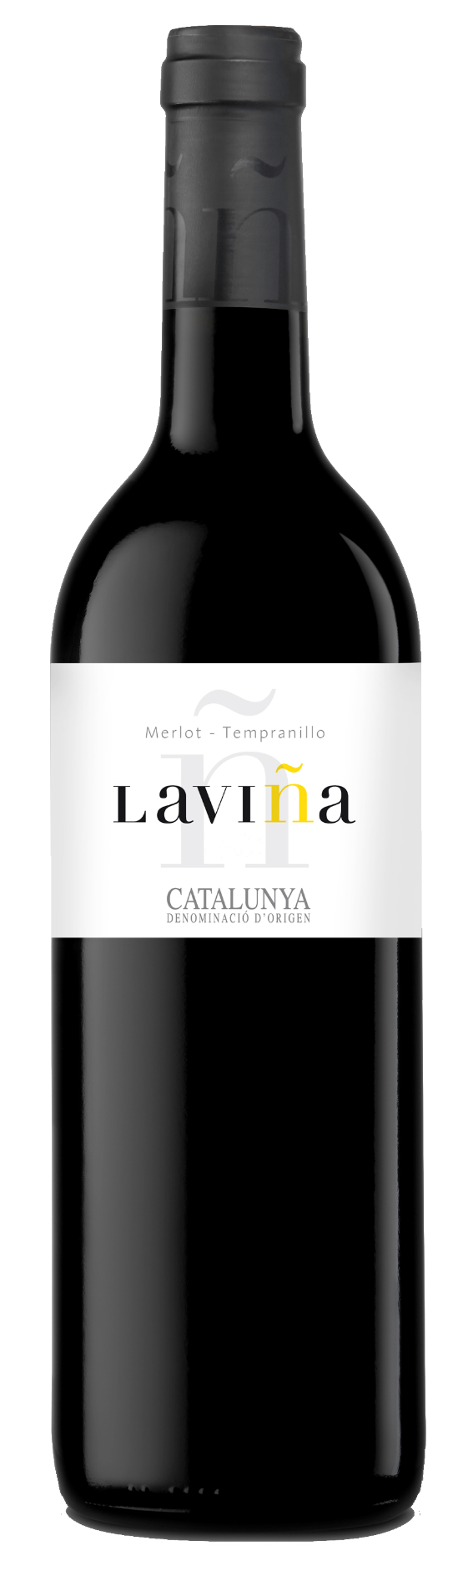

**Winemaking**:

Harvest: Manual and mechanical. Tempranillo: 1st week of September. Merlot: Mid-September.

Fermentation: Semi-carbonic maceration (part of the grapes are fermented without being crashed) at 24 ºC to 26 ºC. Maceration during 8 days to obtain color and aromas.

**Tasting notes:**

In appearance: Intense, deep cherry red color. Clear and bright.

On the nose: Very fruity aroma (strawberry, cherry and blackberry), with floral notes that confer a good aromatic expressiveness.

On the palate: In the mouth it is harmonious, with good body, full of flavours and fresh. A long, elegant aftertaste. Balanced, pleasant and easy to drink.

**UPC 8-95899-00203-3**

**CASE CONTENT: 12x750ML**

**CASE WEIGHT: 33,5 Lb.**

**CASE QTY per pallet LAYER: 15 (75 total)**

***Appellation****: Vilobí de Penedes - Spain*

***Vintage:*** *2018*

***Alcohol:*** *13,0% by Vol.*

***Winery:*** *Vallformosa*

***Winemaker:*** *Xavier Pons*

Laviña

Merlot Tempranillo

T. 704 638-0004 | email: sales@ecovalleyimports.com | www.ecovalleyimports.com

