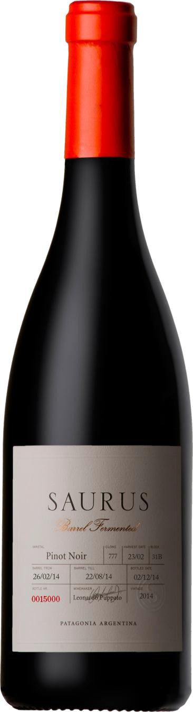
Saurus Barrel Fermented
Pinot Noir

Appellation: Patagonia - Argentina Vintage: Current
Alcohol: 14,0% by Vol.
Winery: Familia Schroeder

“In 1999, during the construction of our winery, fossils of an Aeolosaurus were found at the site. The name comes from the Greek “Aeolo”, which means wind and “Saurus”, which means lizard.
Such an important discovery inspired us to name our first line of wines Saurus!” – Familia Schroeder

Winemaking:

Picked by hand and kept in cold chamber at 0°C until selected in vibratory table. Five days’ alcoholic fermentation in contact with skins, then racked in oak barrels until the fermentation process, including malolactic fermentation, ends. Six-month aging in new barrels, 50% in American and 50% in French oak. The toasting of the barrels was exclusively made for this winery´s use.

Tasting notes:

The eyes meet bright cherry red tones. Red fruit aromas, currants, raspberries and strawberries. The oak fermentation provides notes of vanilla and chocolate with subtle notes of leather in the nose. Very fruity, with sweet tannins in the palate. Rounded, with just enough acidity.

UPC 827599900920
CASE CONTENT: 12x750ML CASE WEIGHT: 37 Lb.
CASE QTY per pallet LAYER: 14 (70 total)

T. 704 638-0004 | email: sales@ecovalleyimports.com | www.ecovalleyimports.com

